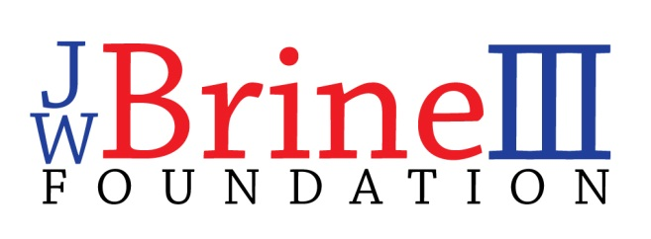
Grant Application

The JWBrine III Foundation has been created in loving memory of Jim Brine who spent his life quietly helping others. Please fill out the following application if you or someone you know is in need of some assistance. Our grant committee will review your request and notify you of our decision. Please know that this information will remain private and will not be shared with anyone, unless approved by the recipient.

Recipient’s Name:______________________________________________________
Recipient’s Address:___________________________________________________
Recipient’s Phone Number: ___________________________________________

Reason for grant request:

Amount Requesting:

How the funds will be used:

Please mail your request to:
JWBrine III Foundation ~ P.O. Box 255 ~ Burlington, MA 01803
Please contact us with any questions:
jwbrineiiifoundation@gmail.com
Check out our web site for more information about our foundation:
www.jwbrineiiifoundation.org

